|  |  |
| --- | --- |
| **CSL2070 Digital Design**  Lab Report | |
| **Roll Number** | **B20CS029** |
| **Name** | **Kulkarni Tanmay Shreevallabh** |
| **Lab number** | **Lab2** |
| **Experiment Title** | **Binary to Gray converter, Gray to binary Converter, Hex to Seven Segment Converter, Two Buzzer System** |

**Binary to Gray Converter (4-bit)**

**Code**

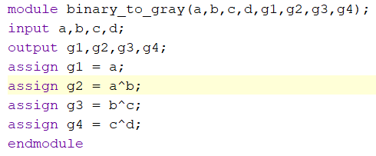

**Code for Test Bench**

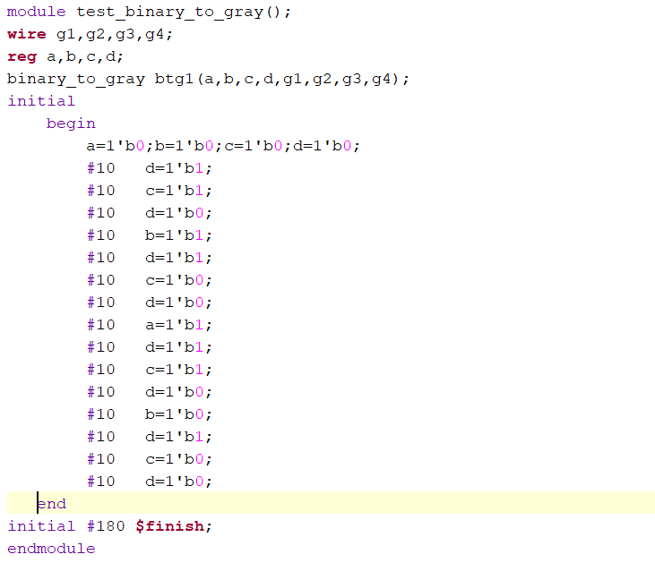

**Waveform**

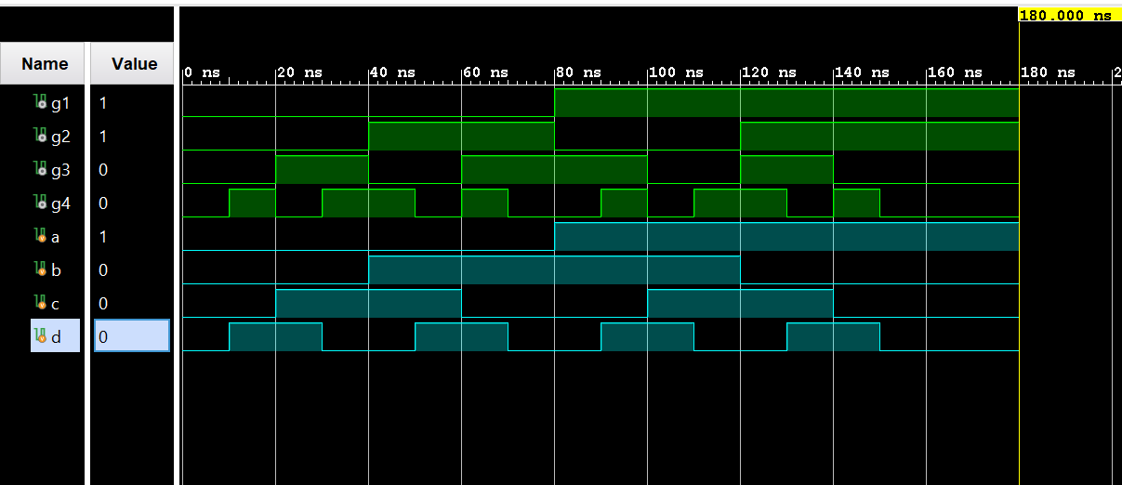

**Gray to Binary (4-bit)**

**Code**

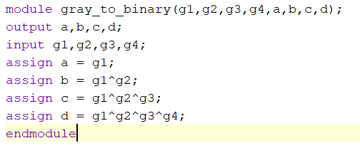

**Code for Test- Bench**

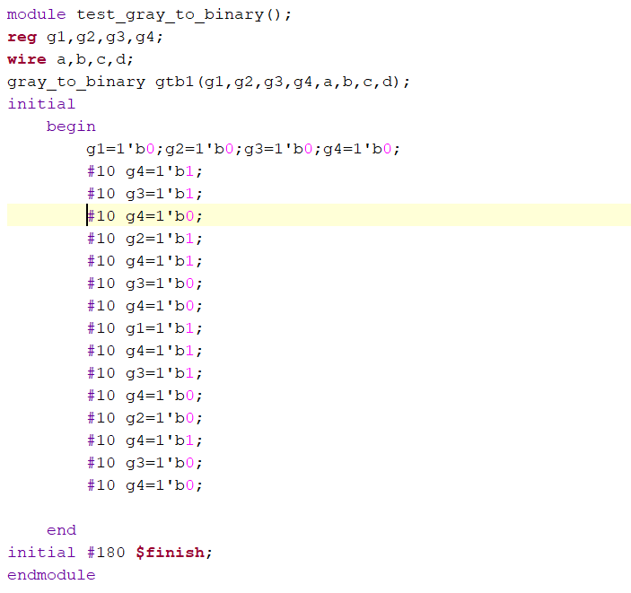

**Waveform**

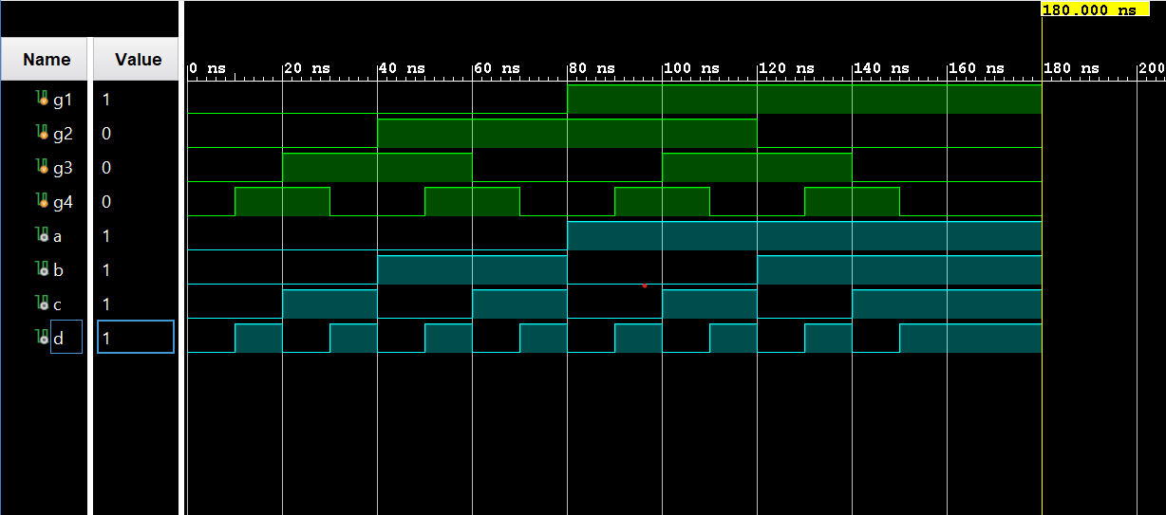

**Hex to Seven Segment converter**

**Code**

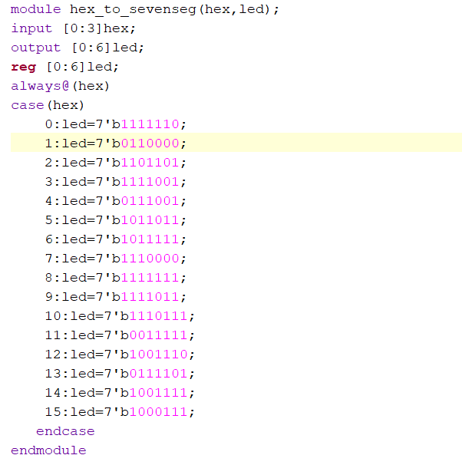

**Two-Buzzer System**

**Code**

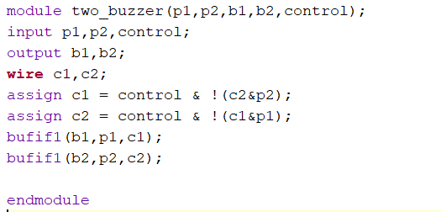

**Code for Test- Bench**

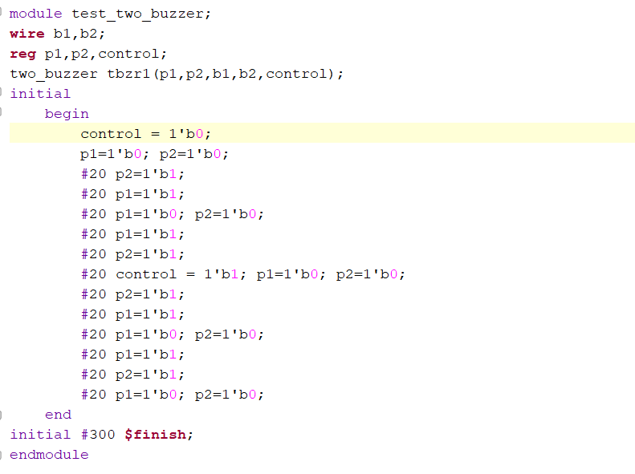

**Waveform**

